Accompaniment Adjunct

✅ What Is an Accompaniment Adjunct?
# Source: AI Source: Provided by: [Data Path: Persons Table -> ID Column: 1, Name_En Column: Motasem Essam] -> From: [Chatgpt (GPT-4-turbo)] on [8/6/2025]
An accompaniment adjunct indicates who or what is with the subject during the action. It adds non-essential detail about companionship or presence, describing who or what accompanies the action.
It answers the question:
- With whom?
- Along with what?

🔸 Common Forms of Accompaniment Adjuncts:
# Source: AI Source: Provided by: [Data Path: Persons Table -> ID Column: 1, Name_En Column: Motasem Essam] -> From: [Chatgpt (GPT-4-turbo)] on [8/6/2025]
- Prepositional Phrases: with her friend, along with the team, in company with his dog
- Coordinated Noun Phrases (less formal): John and Mary, Sam and I

🔸 Examples of Accompaniment Adjuncts in Sentences:
# Source: AI Source: Provided by: [Data Path: Persons Table -> ID Column: 1, Name_En Column: Motasem Essam] -> From: [Chatgpt (GPT-4-turbo)] on [8/6/2025]
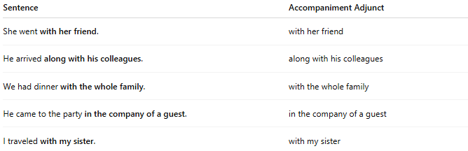
Sentence | Accompaniment Adjunct
She went with her friend. | with her friend
He arrived along with his colleagues. | along with his colleagues
We had dinner with the whole family. | with the whole family
He came to the party in the company of a guest. | in the company of a guest
I traveled with my sister. | with my sister

🔸 Position in the Sentence:
# Source: AI Source: Provided by: [Data Path: Persons Table -> ID Column: 1, Name_En Column: Motasem Essam] -> From: [Chatgpt (GPT-4-turbo)] on [8/6/2025]
- Final (most common): They hiked with their guide.
- Initial (emphatic): With his friend, he entered the room.
- Medial (less frequent): She has, with her dog, walked this path many times.

🔸 Reminder:
# Source: AI Source: Provided by: [Data Path: Persons Table -> ID Column: 1, Name_En Column: Motasem Essam] -> From: [Chatgpt (GPT-4-turbo)] on [8/6/2025]
An accompaniment adjunct adds relational or social context to the action but is not required for grammatical completeness.
🟢 "He went."
🟡 "He went with his friend." → Accompaniment adjunct adds company

